资料信息

Ingress-Nginx github 地址：https://github.com/kubernetes/ingress-nginx

Ingress-Nginx 官方网站：https://kubernetes.github.io/ingress-nginx/

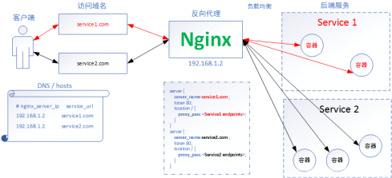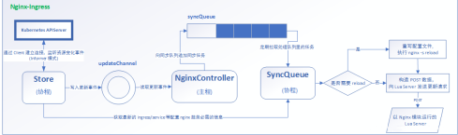部署 Ingress-Nginx

kubectl apply -f mandatory.yaml

kubectl apply -f service-nodeport.yaml

Ingress HTTP 代理访问

deployment、Service、Ingress Yaml 文件

apiVersion: extensions/v1beta1

kind: Deployment

metadata:

name: nginx-dm

spec:

replicas: 2

template:

metadata:

labels:

name: nginx

spec:

containers:

- name: nginx

image: wangyanglinux/myapp:v1

imagePullPolicy: IfNotPresent

ports:

- containerPort: 80

---

apiVersion: v1

kind: Service

metadata:

name: nginx-svc

spec:

ports:

- port: 80

targetPort: 80

protocol: TCP

selector:

name: nginx

---

apiVersion: extensions/v1beta1

kind: Ingress

metadata:

name: nginx-test

spec:

rules:

- host: www1.atguigu.com

http:

paths:

- path: /

backend:

serviceName: nginx-svc

servicePort: 80

Ingress HTTPS 代理访问 创建证书，以及 cert 存储方式

openssl req -x509 -sha256 -nodes -days 365 -newkey rsa:2048 -keyout tls.key -out tls.crt -subj "/CN=nginxsvc/O=nginxsvc"

kubectl create secret tls tls-secret --key tls.key --cert tls.crt

deployment、Service、Ingress Yaml 文件

apiVersion: extensions/v1beta1

kind: Ingress

metadata:

name: nginx-test

spec:

tls:

- hosts:

- foo.bar.com

secretName: tls-secret

rules:

- host: foo.bar.com

http:

paths:

- path: /

backend:

serviceName: nginx-svc

servicePort: 80

Nginx 进行 BasicAuth

yum -y install httpd

htpasswd -c auth foo

kubectl create secret generic basic-auth --from-file=auth

apiVersion: extensions/v1beta1

kind: Ingress

metadata:

name: ingress-with-auth

annotations:

nginx.ingress.kubernetes.io/auth-type: basic

nginx.ingress.kubernetes.io/auth-secret: basic-auth

nginx.ingress.kubernetes.io/auth-realm: 'Authentication Required - foo'

spec:

rules:

- host: foo2.bar.com

http:

paths:

- path: /

backend:

serviceName: nginx-svc

servicePort: 80

Nginx 进行重写

| 名称 | 描述 | 值 |
| --- | --- | --- |
| nginx.ingress.kubernetes.io/rewrite target | 必须重定向流量的目标URI | 串 |
| nginx.ingress.kubernetes.io/ssl redirect | 指示位置部分是否仅可访问SSL（当Ingress包含证书时 默认为True） | 布  尔 |
| nginx.ingress.kubernetes.io/force ssl-redirect | 即使Ingress未启用TLS，也强制重定向到HTTPS | 布  尔 |
| nginx.ingress.kubernetes.io/app root | 定义Controller必须重定向的应用程序根，如果它在'/'上 下文中 | 串 |
| nginx.ingress.kubernetes.io/use regex | 指示Ingress上定义的路径是否使用正则表达式 | 布  尔 |

apiVersion: extensions/v1beta1

kind: Ingress

metadata:

name: nginx-test

annotations:

nginx.ingress.kubernetes.io/rewrite-target: http://foo.bar.com:31795/hostname.html spec:

rules:

- host: foo10.bar.com

http:

paths:

- path: /

backend:

serviceName: nginx-svc

servicePort: 80